# Generated Ideas

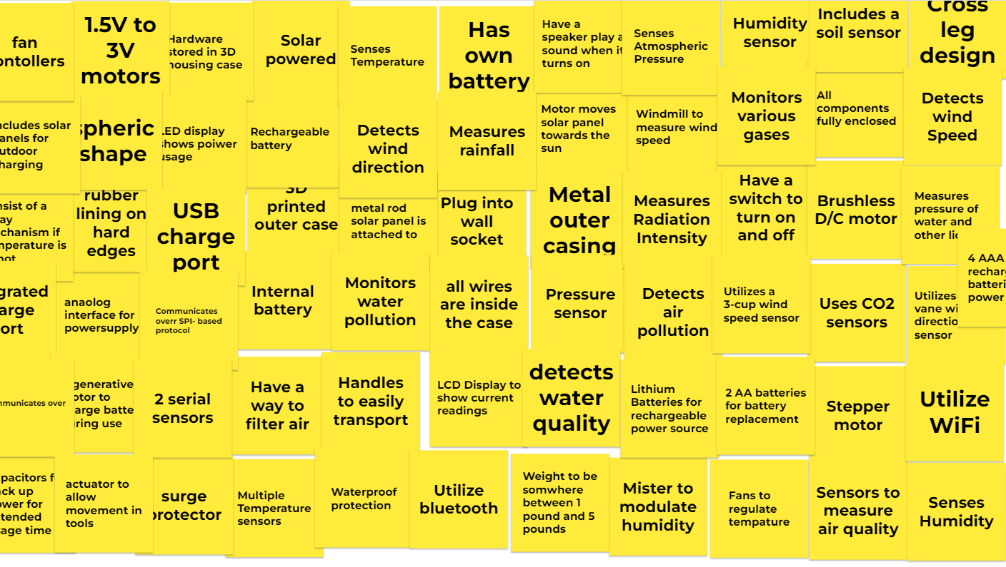

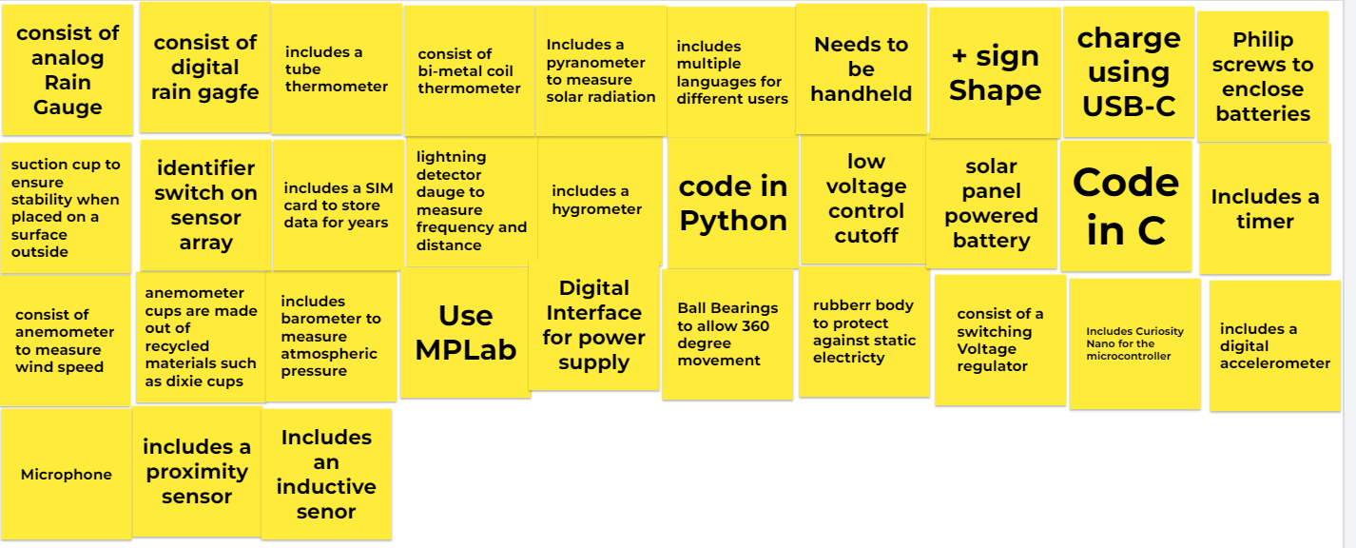

# 

# Sorting Concepts

**Ranking 1 through 4 with 4 being best. Green = 4, Blue = 3, Orange = 2, Yellow = 1**

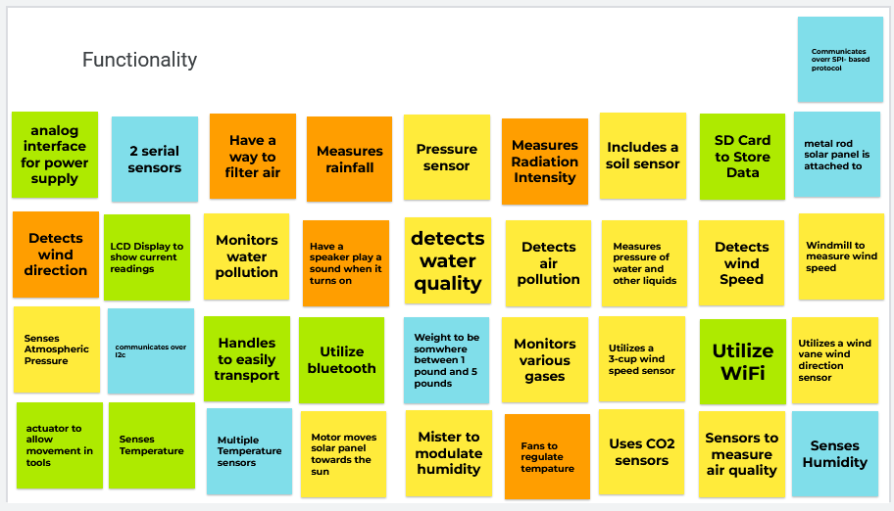

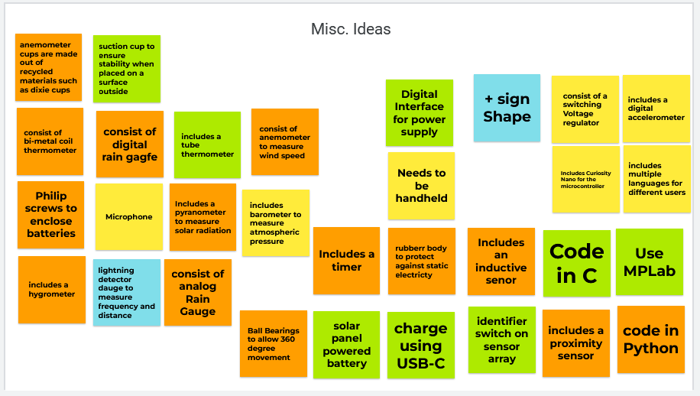

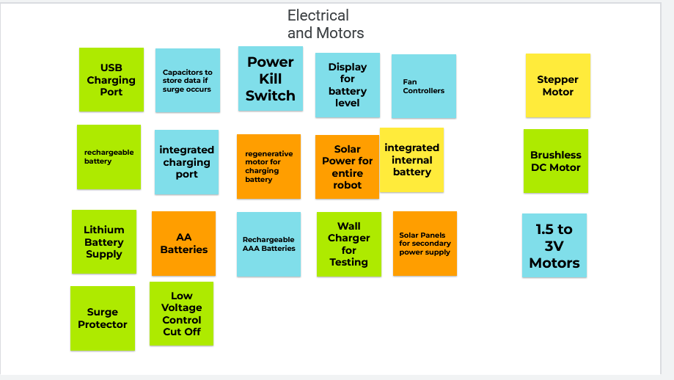

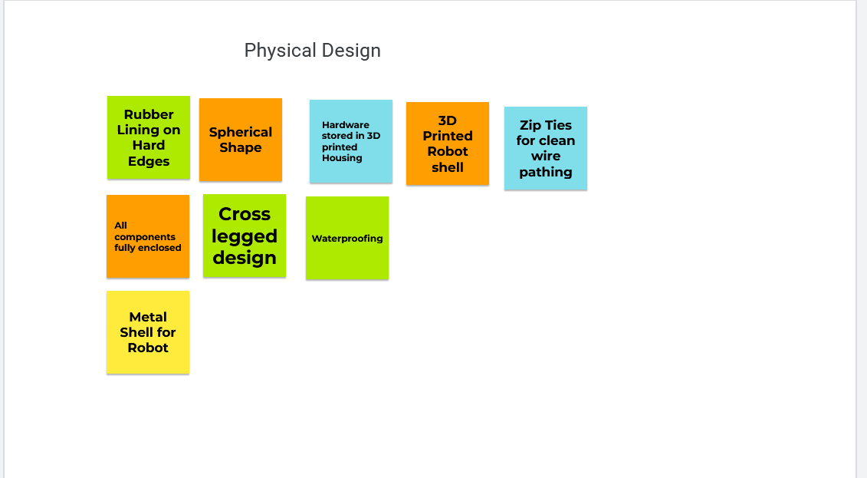

# Concept Sketches

Sketch #1

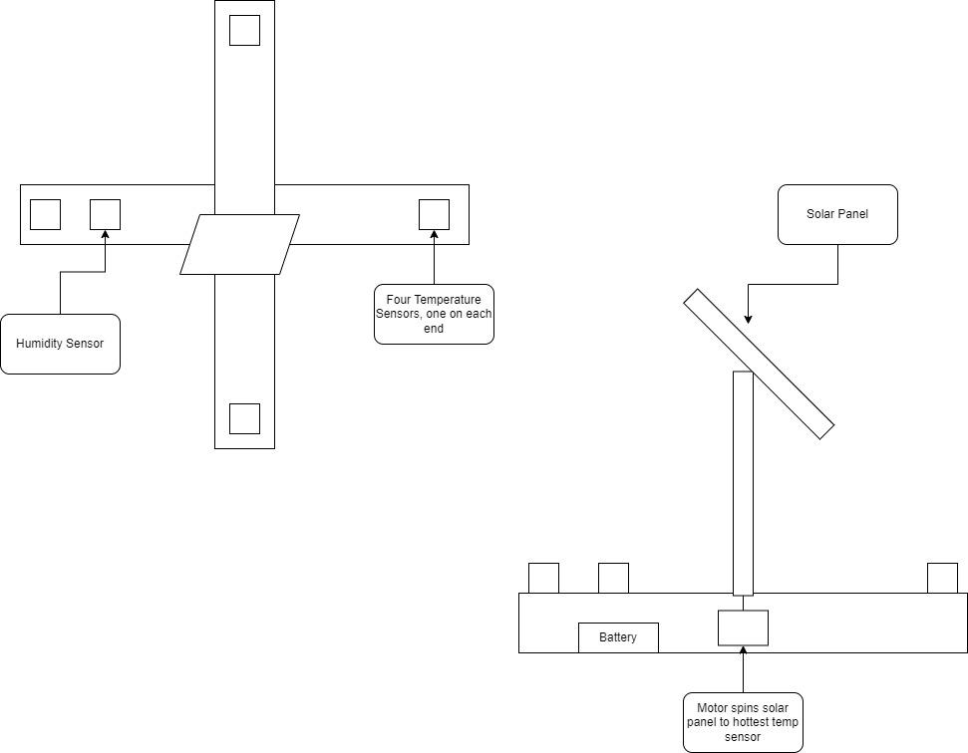

Set up in a + formation with a temperature sensor at each end of the legs. One leg will also have a humidity sensor. There is a motor in the center connected to a rod that a solar panel will be connected to. The motor will spin and turn to face the temperature sensor that is reading the highest temperature as this will most likely be the sensor that is facing the sun.

Sketch #2

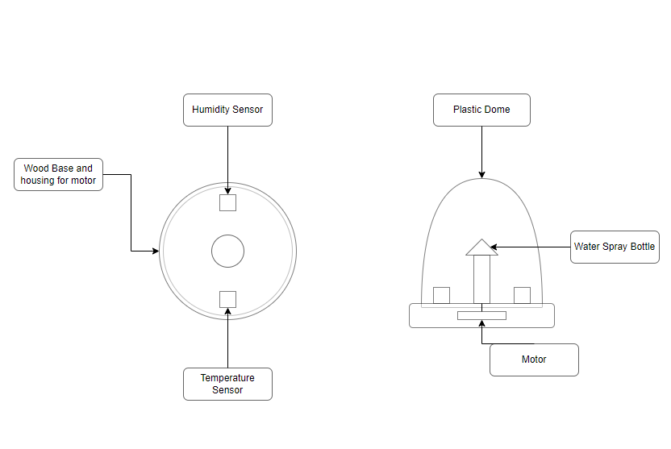

In our second design concept, we will have an enclosed water reservoir with a spray nozzle. The motor will actuate the release mechanism for the mister. A humidity sensor, thermometer, and mister will all be enclosed within a plastic dome. Should the humidity be under a given level at a specified temperature, the motor will activate and mist the dome to bring the humidity to its desired level.

Sketch #3

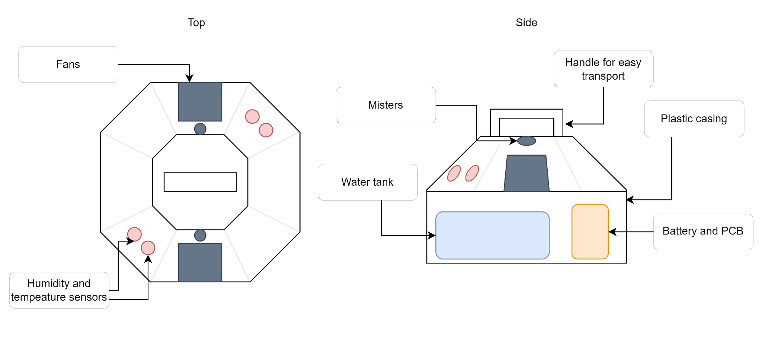

Our third concept, similar to our second, will have an enclosed water tank to be sprayed using a mister. Though this design would measure ambient temperature and humidity and would use a combination of adjusting fan speed and spraying water to reach the desired temperature and humidity levels. The internals will be encased in a plastic octagonal casing with a tapered top where the sensors, misters, and fans will be placed.*